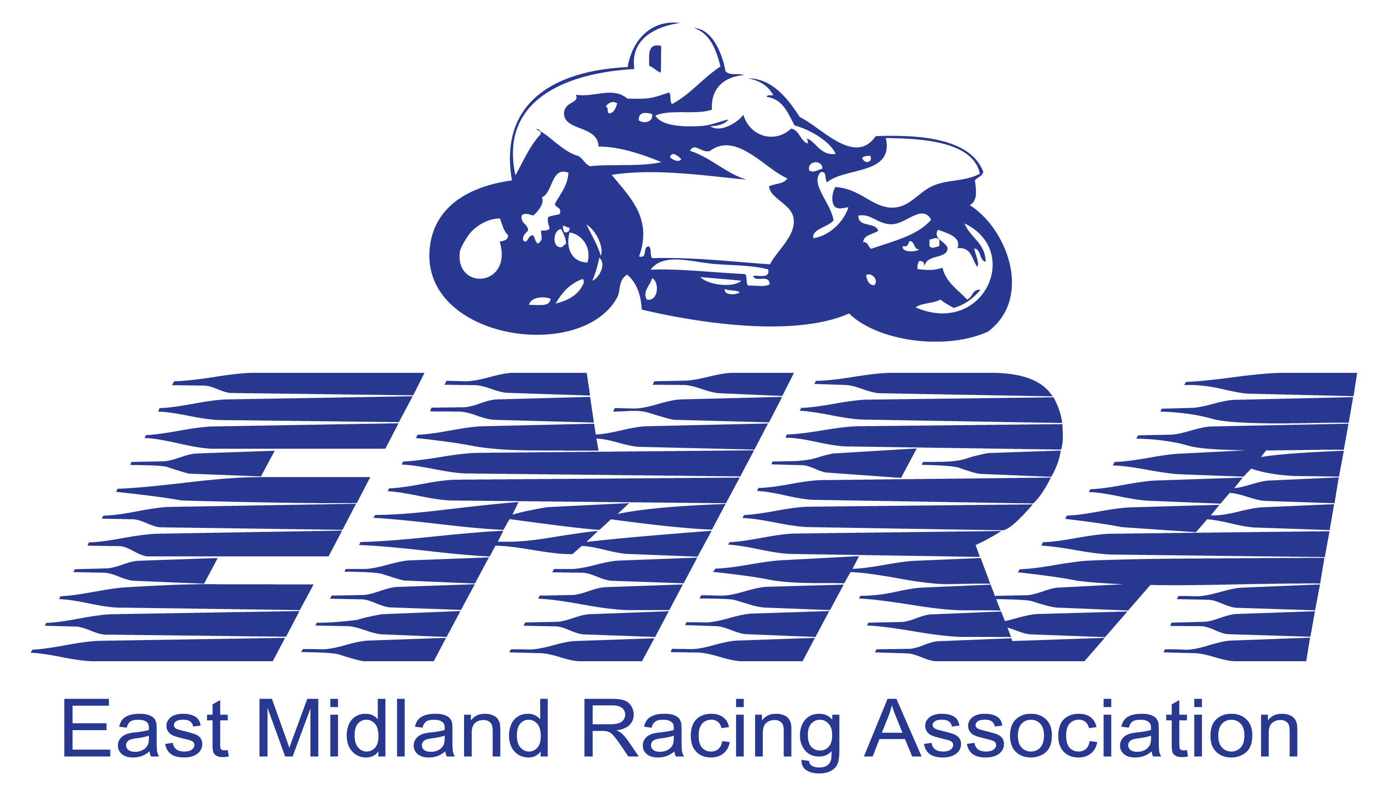
Agreed Race No:
Trans No:
EAST MIDLAND RACING ASSOCIATION
(On behalf of East Midland Centre A.C.U. Ltd.)

Permit No's ACU 46633 OFFICIAL ENTRY FORM P.C.L. No. 002
To be completed and returned not later than fifteen days before the meeting with the correct Entry fee and E.M.R.A. Membership (if necessary) to the Entries Secretariat of the Meeting. Please enclose a Stamped, Self Addressed enveloped no bigger than 240 x 165mm, and return to us along with this entry form in one of the EMRA reply envelopes supplied.
E.M.R.A Restricted Club Road Races, Mallory Park on 20 TH MARCH, 24TH APRIL, 22TH MAY, 17TH JULY, 21ST AUGUST,
11TH SEPTEMBER 2016.
Held under the National Sporting Code of the Auto Cycle Union, the Standing Regulations for Road Racing of the A.C.U (2016 edition) and Supplementary Regulations of E.M.R.A. together with any Final Instructions subsequently issued.

BLOCK CAPITALS PLEASE (to be completed in full)
DRIVERS NAME:
ADDRESS:

POSTCODE:
PASSENGERS NAME: ____________________________
ADDRESS: ___________________________________
___________________________________
___________________________________
POSTCODE: ___________________________________

2016 ACU Licence No: ___________________________
*novice/int.novice/clubman/national. *delete inapplicable
2016 ACU Licence No: ___________________________
*novice/int.novice/clubman/national. *delete inapplicable

EMERGENCY CONTACT NAMEAND NUMBER : ____________________________________________________

CONTACT TELEPHONE NUMBER _________________________________2016 MEMBERSHIP NUMBER _________

I WISH TO ENTER THE FOLLOWING EVENTS: MAKE OF MACHINE CAPACITY
1 | Solo 71-125cc Formula + Classic / Freetech 50cc |  | 11th SEPT 2016 MALLORY PARK
2 | Sidecar 600cc + 1300cc Open
3 | Solo Earlystocks + 175-250 LC
4 | Solo 80-125cc Racing Machines (Moto 3-55BHP)
5 | Solo - Formula Lightweight/Mini Twins
6 | Solo - EMRA 500
7 | Solo - Superstock 600cc & 1000cc
8 | Solo - Buildbase Mallory Trophy 600cc and 1000cc
9 | Solo - Real Motorsport Allcomers Upto 1300cc
10 | Solo - Super-Twins
11 | Solo – Rookies 175cc Upto 1300cc
12 | Solo - Supersport
13 | Solo - Junior / Senior Road Stock
14 | Solo - Steel Framed & Pre-injection Formula 600cc
15 | FSRA F350 Post Classic Pre Inj Sidecars
ENTRY FEE Event No. Amount
FIRST SOLO EVENT £150
EACH ADDITION SOLO EVENT £30
SIDECAR EVENT £175
BRITISH SIDECAR CHAMPIONSHIP £175
E.M.R.A. MEMBERSHIP DRIVER OR PASSENGER £15.00 EACH
LATE ENTRY FEE (if less than seven days before meeting) £10.00
PAY ON THE DAY ENTRIES MUST INCLUDE A £20 DEPOSIT | TOTAL | £

PLEASE DO NOT FORGET TO SIGN THE BACK OF THE FORM

Entry declaration: I the undersigned apply to enter the event described overleaf and in consideration thereof:-
I hereby declare that I have had the opportunity to read, and that I understand the National Sporting Code of the ACU, the ACU Standing Regulations, such Supplementary Regulations as have or may be issued for the event, and agree to be bound by them.
I further, declare that I am physically and mentally fit to take part in the event and I am competent to do so. I confirm that I am not currently suspended from ACU permitted competition or on the ACU STOP LIST as a result of incurring a concussion injury.
I confirm that I understand the nature and type of event I am entering and its inherent risks and agree to accept the same notwithstanding that such risks may involve negligence on the part of the organisers or officials.
I accept that insurance arranged on my behalf by the organisers of events that I may enter specifically excludes liability between the participants. I understand that this form may be used in litigation as evidence that any serious injury will be principally the result of my voluntary decision to engage in a high risk activity.
I consent to details of any injuries I may suffer at this event being passed between all medical services and the Clerk of the Course.
I consent to the collection and retention of my personal information by the ACU.

I confirm that if any part of the event takes place on a public highway, the machine(s) described below shall be insured as required by the Road Traffic Acts, or equivalent legislation, and that it / they will comply with the regulations in respect thereof. I/We confirm that I/We are not suspended from competition in ACU permitted events.
I confirm that the machine(s) as described overleaf, which I participate on shall be suitable and proper for the purpose.
I/We confirm that I/We are eligible to compete on the machines for which I/We have entered.
I accept responsibility for any items borrowed from the Organiser during the course of the event. These items include but are not restricted to (safety clothing, transponders, accessories). I understand that I am liable for the cost or replacement of any items lost or not returned and non-payment or non-replacement of items borrowed may affect my entry into subsequent events.
I confirm that I have not been refused an ACU Licence, nor had an ACU Licence suspended, nor have I been excluded from any ACU competition.

Acknowledgement of the risks of motorsport: I understand that by taking part in this event I am exposed to a risk of death, becoming permanently disabled or suffering some other serious injury and I acknowledge that even in the event that negligence on the part of the ACU, the promoter, the organising club, the venue owner, or any individual carrying out duties on their behalf were to be a contributory cause of any serious injury I may suffer, the dominant cause of any serious injury will always be my voluntary decision to take part in a high risk activity.

I have read the above and acknowledge that my participation in motorsport is entirely at my own risk. I agree that I am required to register on arrival by “signing on” at the designated place before taking part in any Practice Session or Race.

Rider's signature:…………………………………………………. Date of Birth…………………….
If under 18 Print name of Parent or Guardian……………………………………………………………
Signature of Parent or Legal Guardian ……………………………………………………………….

Passenger's signature: …………………………………………….. Date of Birth …………………
If under 18 Print name of Parent or Guardian……………………………………………………………
Signature of Parent or Legal Guardian ……………………………………………………………….

In addition to this entry form, Riders and Passengers under 18 years of age must also complete a 'Parental Agreement Form' giving permission for them to compete. Their parents or legal guardian must also accompany them for the duration of the meeting. Parental Agreement forms are available from the organisers and from the ACU.

SEND ALL CHEQUES PAYABLE TO EAST MIDLAND CENTRE A. C. U. Ltd. FOR CREDIT OR DEBIT CARD PAYMENTS (subject to surcharge) : CONTACT IAIN ON 02476 317273 FORMS TO BE SENT IN ENVELOPE PROVIDED (STAMP REQUIRED) AT LEAST TEN DAYS BEFORE THE MEETING

ENTRIES SECRETARY
lain Rankin. 55 Robert Road, Exhall, Coventry. CV7 9GT. TEL: 02476 317273

DO NOT FORGET TO ENCLOSE A STAMPED ADDRESSED ENVELOPE FOR RETURN PAPERWORK

CHANGE OF RIDER, PASSENGER OR MACHINE. It is not permitted to change a rider, passenger, make or capacity of motorcycle, after the start of any meeting (see National Sporting Code).
In the event of any driver, passenger or entrant cancelling an entry they MUST send ALL passes and paperwork to the ENTRIES SECRETARIAT of the meeting to arrive at least 48 hours before the date of the event. NO REFUND WILL BE CONSIDERED AFTER THE CLOSE OF THE MEETING. A MINIMUM £20:00 administration fee and the value of any unreturned passes will be deducted from all cancelled entries. (See regulation sheet for information).

